21)
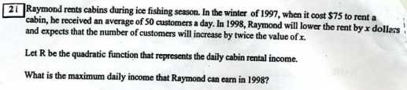
make a chart with 3 columns labeled
a) # of customers per day b) rental income per customer c) total daily income

Before the rent lowering : a) 50 c/d b) $75 c) 50 × $75
After the rent lowering : a) (50 + 2x) c/d b) $(75 – x) c) (50 + 2x) (75 – x) = R(x)
now find the x that maximizes this parabola. If you're smart, you'll use the zeros which you can see from the function rule – take their midpoint which is h -- and you'll have the answer. It's x = $25. then find R($25).

9)
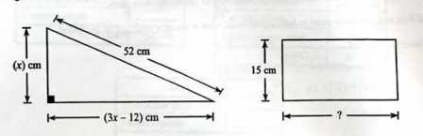
Let b represent the length of the rectangle's base.
This means the area of the rectangle = 15b.
In the triangle, we know that the length of the hypotenuse = 52
We also know that the sum of the squares of the other two sides = 52²,
so we write the quadratic equation stating this. (3x – 12)² + x² = 52² (soln is x = 20)
hint: factor the first bracket to [3(x – 4)]² to get 9(x – 4)²
Once we find the value of x, we can find the area of the triangle. Set this number = 15b and solve for b.

